|  |  |  |  |  |  |  |  |  |
| --- | --- | --- | --- | --- | --- | --- | --- | --- |
|  | 3.3 | 3.07 | 2.62 | 1.14 | 0.87 | 0.57 | 0.2 | If (A) |
| 408 | 388 | 370 | 345 | 260 | 214 | 144 | 51 | Vt (v) |

**جدول ها و نمودارها**

**جدول 1**

|  |  |  |  |  |  |  |  |
| --- | --- | --- | --- | --- | --- | --- | --- |
| 1.8 | 1.6 | 1.2 | 1 | 0.6 | 0.4 | 0.2 | If (A) |
| 0.46 | 0.39 | 0.31 | 0.25 | 0.15 | 0.09 | 0.04 | Isc (A) |

**جدول 2**

**ثابت If = 2 A =**

|  |  |  |  |  |  |  |  |  |  |
| --- | --- | --- | --- | --- | --- | --- | --- | --- | --- |
| 1500 | 1450 | 1350 | 1300 | 1250 | 1200 | 1150 | 1060 | 1000 | n(rpm) |
| 0.44 | 0.45 | 0.44 | 0.43 | 0.43 | 0.44 | 0.43 | 0.43 | 0.44 | Isc (A) |

**جدول 3**

**ثابت If= 4.5 (A)=**

|  |  |  |  |  |  |  |  |  |
| --- | --- | --- | --- | --- | --- | --- | --- | --- |
| 8 | 7 | 6 | 5 | 4 | 3 | 2 | 1 | پله­های بار مقاومتی |
| 358 | 367 | 370 | 376 | 394 | 395 | 394 | 410 | Vt (v) |
| 0.59 | 0.53 | 0.47 | 0.4 | 0.32 | 0.24 | 0.16 | 0.07 | Ia (A) |

**جدول 4**

**ثابت If= 4.5 (A)=**

|  |  |  |  |  |  |  |  |
| --- | --- | --- | --- | --- | --- | --- | --- |
| 2 | | | | | | پله­ بار مقاومتی | |
| 4 | 3 | 2 | 1 | پله­های بار خازنی | |
| 460 | 441 | 437 | 396 | Vt (v) | |
| 0.49 | 0.4 | 0.32 | 0.18 | Ia (A) | |

**جدول 5**

**ثابت If= 4.5 (A)=**

|  |  |  |  |  |  |  |
| --- | --- | --- | --- | --- | --- | --- |
| 2 | | | | پله­ بار مقاومتی | | |
| 4 | 3 | 2 | 1 | | پله­های بار سلفی |
| 346 | 370 | 383 | 394 | | Vt (v) |
| 0.31 | 0.26 | 0.21 | 0.17 | | Ia (A) |

**جدول 6**

|  |  |  |  |  |  |  |  |  |
| --- | --- | --- | --- | --- | --- | --- | --- | --- |
| 1 | | | | | | | | T (N.m.) |
|  |  |  | 1.8 | 2 | 2.4 | 3 | 3.6 | If (A) |
|  |  |  | 0.54 | 0.51 | 0.46 | 0.39 | 0.42 | Is (A) |
|  |  |  | 0.86 | 0.9 | 0.85 | 0.9 | 0.99 | Cos φ |

**جدول 7**

|  |  |  |  |  |  |  |  |  |
| --- | --- | --- | --- | --- | --- | --- | --- | --- |
| 0.5 | | | | | | | | T (N.m.) |
|  |  | 1.8 | 2 | 2.4 | 2.8 | 3.2 | 3.6 | If (A) |
|  |  | 0.39 | 0.36 | 0.34 | 0.33 | 0.33 | 0.29 | Is (A) |
|  |  | 0.8 | 0.83 | 0.9 | 0.95 | 0.99 | 1 | Cos φ |

**جدول 8**

|  |  |  |  |  |  |  |  |  |
| --- | --- | --- | --- | --- | --- | --- | --- | --- |
| 1.5 | | | | | | | | T (N.m.) |
|  |  | 1.8 | 2 | 2.2 | 2.6 | 3 | 3.6 | If (A) |
|  |  | 0.83 | 0.89 | 0.92 | 1 | 1.04 | 1.16 | Is (A) |
|  |  | 0.87 | 0.82 | 0.78 | 0.81 | 0.84 | 0.85 | Cos φ |

**جدول 9**

|  |  |  |  |  |  |  |  |  |
| --- | --- | --- | --- | --- | --- | --- | --- | --- |
| 2 | | | | | | | | T (N.m.) |
|  |  | 1.8 | 2 | 2.4 | 2.8 | 3 | 3.6 | If (A) |
|  |  | 0.96 | 1.01 | 1.04 | 1.07 | 1.17 | 1.24 | Is (A) |
|  |  | 0.82 | 0.86 | 0.87 | 0.87 | 0.86 | 0.86 | Cos φ |

**جدول 10**

**نمودار 1**

**نمودار 2**

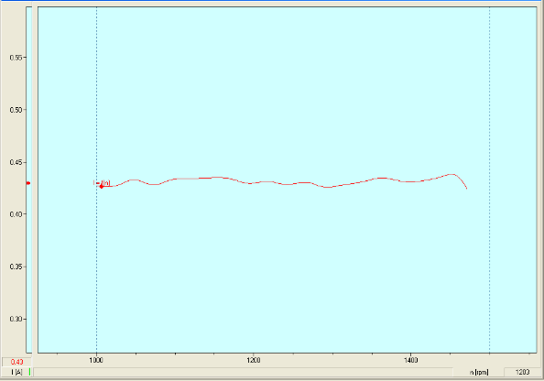

**نمودار 3**

**نمودار 4**

**نمودار 5**

**نمودار 6**

**نمودار 7**

**به نام خدا**



**دانشگاه صنعتی شریف**

**دانشکده مهندسی برق**

**آزمایشگاه تبدیل انرژی الکتریکی 1**

**استاد : جناب دکتر تهامی**

**گزارش آزمایش 3 ( تعیین مشخصه های ماشین سنکرون )**

**تهیه و تنظیم : مصطفی محسنی کبیر(91102396)**

**تاریخ انجام آزمایش: 2 اردیبهشت 1393**